Title of Poster for TCS7

First Author¹*, Another Author², Last Author²
¹Department of Mechanical Engineering, University of Nowhere, Anytown, Country
²Another Department, Another Institute, Town, Country
Corresponding author: a.author@university.ac.de

Abstract
This template illustrates the formatting of posters for TCS7. Please do not change any formatting, such as margins. The abstract should be no longer than one A4 page including text, figures, and references. Minimum length is 400 words.
Your manuscript must be submitted in PDF file format by email. The maximum file size must not exceed 4 MB. Do not include page number, header or footer. Poster boards have a size of 1 m wide and 2.5 m height.
The title of the paper is centered text, Arial, font size 14, bold. Authors and institutes are centered text, Arial, font size 11, followed by 1 blank line. Headlines are formatted Arial, font size 9, bold while the text itself is not in bold. The line spacing is 1.15 without spacing before or after a paragraph. If you wish to highlight any text, only use italics.
You may rename the headlines of each paragraph and/or add new ones. You may insert figures (see Figure 1) or tables in the text.

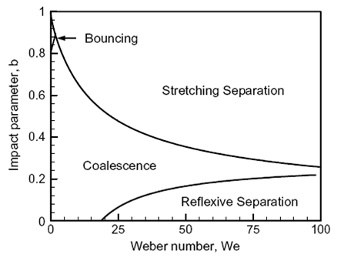

Figure 1. Example figure. Caption in Arial, font size 8, centered, Figure and figure number bold. Spacing before caption is 6 pt.

The example in Figure 1 shows how to include a figure into the text. You should use 1 blank line before and after the figure. The same applies to tables.
Please use SI units in all text, figures and tables. Equations should be left-aligned, with the equation number in parentheses in sequential order included right-justified, as in the below equation,

$F=ma.$ (1)

Equations should be referred to by equation numbers. All symbols should be printed in italics or otherwise according to conventional practice, both in the equations and in the text. There is a spacing of 6 pt. before and after each formula. The nomenclature section should immediately precede the references.

References
References should be indicated in the text by full sized numbers enclosed within square brackets as illustrated in the examples below.

[1] Dukowicz, C. H., and Reitz, R. D., 1999, Atomization and Sprays, 9, pp. 497-517.
[2] Wilcox, D. C., 1993, ``Turbulence Modelling for CFD''. DCW Industries, Inc.

